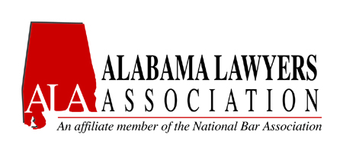

presents

ECONOMIC EMPOWERMENT SUMMIT
A Component of the Financial Literacy Series

Saturday, February 23, 2018
9:30 AM - 3:30 PM

Baker Donelson
Bearman Caldwell & Berkowitz, P.C.
420 20th Street North
1400 Wells Fargo Tower
Birmingham, Alabama 35203

Time | Topic | Presenters
9:15 AM - 9:30 AM | Arrival/Check-in/ Registration
9:30 AM - 9:40 AM | Welcome and Outline the State of the African-American Economy | Marcus M. Maples, Shareholder, Baker Donelson
9:40 AM - 10:20 AM | How to Create Wealth -  Part I (Start Saving) | Terry Smith, Branch Manager, BB&T
10:20 AM - 10:30 AM | Break
10:30 AM - 11:30 AM | How to Create Wealth -  Part II (Protect & Grow Your Wealth) | Thomas E. Hampton,  H20LS Wealth Management Solutions, LLC
11:30 AM -  11:45 AM | Break
11:45 AM - 1:00 PM | Luncheon: The Importance of Black-Owned Businesses:  Black CEOs Speak | Jerry A. Mitchell, CEO, Alabama State Black Chamber of Commerce.
1:00 PM -  1:10 PM | Break
1:10 PM -  1:30 PM | Economic Diversity Issues on a State Level | Nichelle Williams Nix  Director of Office of Minority Affairs for the State of Alaabama
1:30 PM - 2:05 PM | Leave a Legacy for Future Generations - Part I | Blair E. Liggins,  AVP & Trust Officer,  Regions Wealth Management - Signature Trust Services
2:05 PM - 2:35 PM | Leave a Legacy for Future Generations -  Part II | Lyord Watson, Jr.,  CEO, The Penny Foundation
2:35 PM - 3:05 PM | Branding For Financial Success | G. Courtney French,  V94.9 Broadcasting Network,  Chris Coleman and Tracy Hardy.
3:05 PM -  3:15 PM | Break
3:15 PM - 3:45 PM | Restoring Our Communities | Bettina Byrd-Giles  Co-Founder, Ensley Alive
4:00 PM - 4:05 PM | Closing Remarks | Marcus M. Maples,  Shareholder, Baker Donelson
4:30 PM - 5:00 PM | Quarterly Business Meeting  *ALA Members Only | Marcus M. Maples,  Shareholder, Baker Donelson

