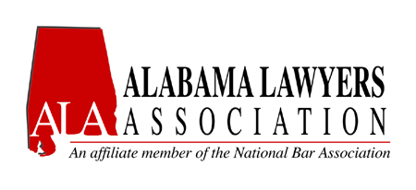
Leadership Interest Form

Name (First/Middle Initial/Last): __________________________________

ALA Leadership Position seeking (check one):

+President-Elect (1-year Term) _________
+Vice President (1-year Term) _________
Secretary (1-year Term) _________
Assistant Secretary (1-year Term) ________
Treasurer (1-year Term) _________
Parliamentarian (1-year Term) _________
NBA Liaison (1-year Term) _________
(2) Northern District Representatives (1- year Term) _________
(2) Middle District Representatives (1- year Term) _________
(2) Southern District Representatives (1- year Term) _________
ASB Indigent Defense Liaison _________
Alabama Sentencing Commission _________

Contact Information:

Address: ______________________________________________________

City: ____________________ State: _______ Zip: ___________________

Telephone Number: _______________ Alternate Telephone Number: ____________

E-Mail Address: ____________________________

Note: Anyone seeking a leadership position must be a regular member of the Association in good standing at the time of election and must meet the requirements of the office sought, as stated in Bylaws of the Association.

This interest form will assist the current President-Elect of the Association in choosing the slate of officers for a proposed ballot. Individuals not selected by the President-Elect may be nominated from the floor during the election at the Annual Meeting of the Association.

+ Must have been in good standing for a period of at least three (3) years prior to election.

Please email completed Leadership Interest Forms to the Nominations Committee Chairperson, Mark Debro, at mdebro@graceattys.com on or before Friday, May 16, 2014.

